SESSION 2: C PROGRAMMING ASSIGNMENT

- Install GCC on your computer and verify the installation by running gcc --version in your terminal or command prompt.

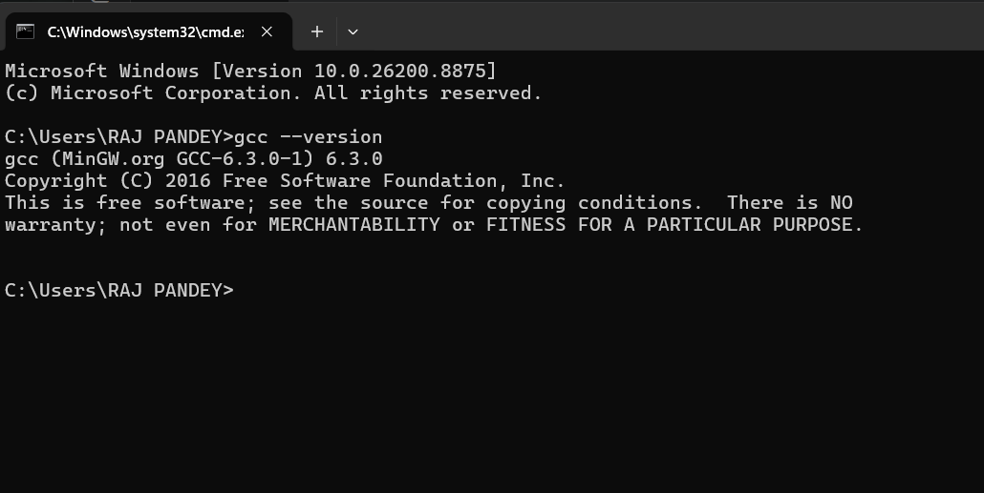

2.Open VS Code or DevC++ and create a new file named hello.c. Write a C program that prints 'Hello, Instagram World!' to the console.

3.Identify and label the header, main function, and return statement in your hello.c program using comments.

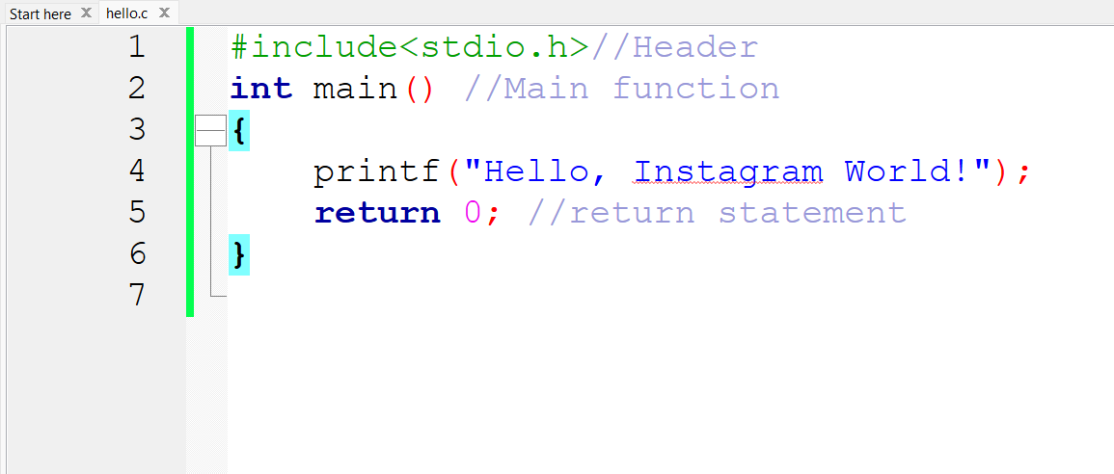

4. Compile your hello.c file using the GCC command line (gcc hello.c -o hello) and run the output file to display the message in your terminal.<br><br><em><strong>Hint:</strong> On Windows, the output file will be hello.exe; on Linux/Mac, it will be hello.</em>

